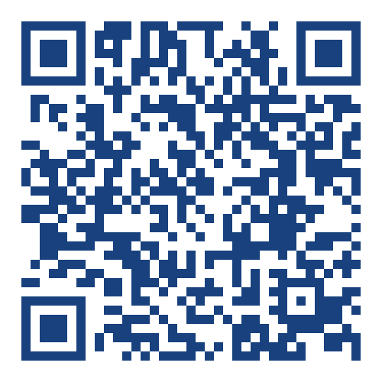 | Advances in Neutrosophic Mathematics and Informatics (ANMI)  Vol.1, Issue 1, March 2026  DOI: https://doi.org/10.64060/ANMI.V1i1.1 | 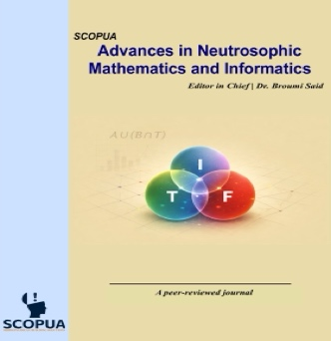

Title of Article
Author One ^{1*}, Auhtor Two ², Author Three ³
¹Affiliation details of Author One
²Affiliation details of Author Two
³Affiliation details of Author Three
* Corresponding Email:
Received: 01 September 2025 / Revised: 06 December 2025 / Accepted: 10 December 2025 / Published online: 18 December 2025
This is an Open Access article published under the Creative Commons Attribution 4.0 International (CC BY 4.0) (https://creativecommons.org/licenses/by/4.0/). Advances in Neutrosophic Mathematics and Informatics published by SCOPUA (Scientific Collaborative Online Publishing Universal Academy). SCOPUA stands neutral with regard to jurisdictional claims in the published maps and institutional affiliations.

ABSTRACT
Abstract section here
Keywords:Keyword 1; Keyword 2; Keyword 3; Keyword 4

- Introduction
Introduction section and so on, other sections of the manuscript will be here (Times New Roman – Font Size 11)
2. Methodology
Introduction section and so on, other sections of the manuscript will be here
3. Results
Introduction section and so on, other sections of the manuscript will be here

References
References in APA style will be here (Times New Roman – Font Size 10)

Declarations
Competing Interests: The authors declare that they have no known competing financial interests or personal relationships that could have appeared to influence the work reported in this paper. OR The authors declare that they have [detail of competing interests].
Declaration of AI Use: The authors declare that the AI tool [name and version of tools] was used [for language editing and readability improvement / to assist with drafting and restructuring sections, summarizing background literature, and improving the fluency of the text / both in the writing and methodological stages / preparation, writing, or analysis] in the preparation of this manuscript. The tool did not generate original research ideas, research data, analyses, or conclusions. All content was critically reviewed, verified, and edited by the authors, who take full responsibility for the accuracy and integrity of the work. OR Not Applicable.
Funding Statement: This research did not receive any specific grant from funding agencies in the public, commercial, or not-for-profit sectors. OR This research received a grant from [detail of grant, organization and grant number, etc.].
Data Availability Statement: Data will be made available on request from the corresponding author.

Ethical Approval & Consent to Participate: All procedures performed in this study involving human participants followed the ethical standards of the institutional review board of [organization /university detail]. The ethics committee of the [department /institute] approved this study [reference/approval number]. All participants were informed that their responses would be kept anonymous and confidential and that the data would only be utilized for the study [study details]. OR Not Applicable.
Informed Consent: Informed consent from all participants was obtained. All participants were above the age of 18 years. OR Not Applicable.
Consent to Publish: Consent to publish has been obtained. OR Not Applicable.
Clinical Trial Number: Provides the unique registration number and registry name for clinical trials to ensure transparency in medical research. OR Not Applicable.
Author Contribution Statement: [Author 1], [Author 2], and [Author 3] conceived the idea and designed the research; Analyzed interpreted the data and wrote the article. OR Not Applicable.
Acknowledgments: Write acknowledgments if applicable. OR Not Applicable.
Disclaimer: Clarifies that the views expressed in the article are those of the authors and do not necessarily reflect the official policy of their institutions or funding bodies. OR Not Applicable.
Availability of Materials and Code: Specifies if custom code, software, or unique biological materials used in the study are available to other researchers. OR Not Applicable.

Author(s) Bio / Authors’ Note
Brief Author's Bio / Author's Note here of max 150 words for each author

